
The 6th International Conference on

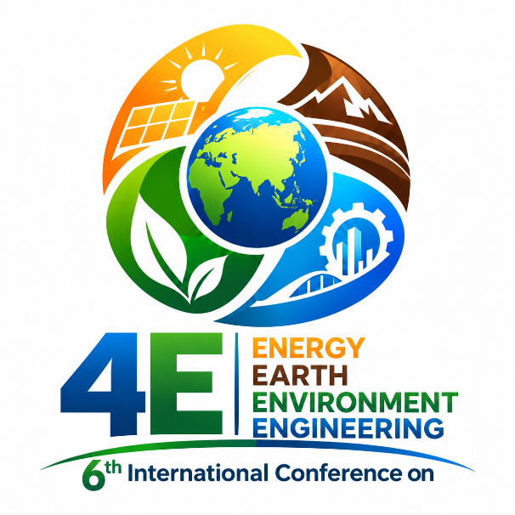
TOPICS:
- Renewable Energy & Energy Conversion
- Chemical and Environmental Technologies
- Earth Resources Engineering
- Metallurgy and Material Science

ORGANIZERS:
 |  | 

3–4 December 2026
Tashkent, Uzbekistan
The 6th International Conference on
“Energy-Earth-Environment-Engineering”

3–4 December 2026
Tashkent, Uzbekistan

TOPICS
Renewable Energy & Energy Conversion
Chemical and Environmental Technologies
Earth Resources Engineering
Metallurgy and Material Science

ORGANIZERS
 | UJICY (Uzbek-Japan Innovation Center of Youth)
 | Tashkent State Technical University named after Islam Karimov
 | JICA (Japan International Cooperation Agency)

SCOPE
The 6th International Conference “Energy-Earth-Environment-Engineering” will be held on 3–4 December 2026 at the Uzbek-Japan Innovation Center of Youth in Tashkent, Uzbekistan.
The conference will bring together researchers from around the world who are interested in interdisciplinary research in energy, earth resources, chemical and environmental engineering, metallurgy, and materials science. It aims to foster interaction and collaboration among researchers from industry, national laboratories, and academia, and to encourage future international research partnerships.
The following topics, as well as related areas, are welcome:
- Renewable Energy & Energy Conversion
- Chemical and Environmental Technologies
- Earth Resources Engineering
- Metallurgy and Material Science

IMPORTANT DATE Abstract Submission Deadline: November 10, 2026
We look forward to welcoming professors, researchers, and students to this joint conference.

SCHEDULE AT A GLANCE
December 3
Reception of international guests at the airport and transfer to their hotels
Small meetings at UJICY
Dinner
Registration
Opening remarks
Plenary lecture: 20 minutes (including discussion)
Invited lecture: 15 minutes (including discussion)
Coffee break
Oral presentation: 10 minutes (including discussion)

December 4
Poster session
Closing ceremony

GENERAL INFORMATION
Official language: English.
The Scientific Programme Committee will organize both oral and poster sessions in a hybrid format, combining in-person presentations with an online component.
Abstract submission: Authors are requested to submit a one-page abstract in A4 format. Authors are strongly encouraged to use the provided template. The abstract should be sent as an email attachment to the Conference Secretariat at seminar.ujicy2021@gmail.com by 10 November 2026.
Participants who wish to take part online may present via Zoom or record a video presentation and send it to the Conference Secretariat.
If printing is required, posters should be sent to the Conference Secretariat in advance. Registration is required for all participants, including speakers.

Please register by email at seminar.ujicy2021@gmail.com

REGISTRATION FORM

The 6th International Conference on
“Energy-Earth-Environment-Engineering”

3–4 December 2026
Tashkent, Uzbekistan

First Name
Last Name
Organization
Country
E-mail
Phone
Position
Plenary lecture 20 min
• Presentation
• Video presentation
• Zoom presentation
Invited lecture 15 min
• Presentation
• Video presentation
• Zoom presentation
Oral presentation: 10 minutes (including discussion)
• Presentation
• Video presentation
• Zoom presentation

Title (Times New Roman, 14 pt)

First Authorᵃ, Second Authorᵇ, Third Authorᵇ

ᵃInstitute, Tashkent, Uzbekistan
ᵇInstitute, Grenoble, France

Author@mail.com

The abstract must be written in English and fit on one A4 page. It should include a brief and clear concluding statement. All abbreviations must be defined at first use.
This example illustrates the required abstract layout. Use single spacing throughout and set all page margins to 2.5 cm. Use Times New Roman, 12 pt.
Centre the title, authors, affiliations, and addresses. Set the title in bold capital letters and underline the presenting author’s name. Leave one blank line between the title and the authors, between the authors and the affiliations, and between the affiliations and the abstract text. List each affiliation in the following order: institution, department, and country.
Justify the abstract text.
Figures may be included, but they must fit within the printable area.
Format references as shown in example [1], using Times New Roman, 10 pt. Leave one blank line between the abstract text and the references. If applicable, add an Acknowledgements section after the references, using Times New Roman, 10 pt.

[1] A. First, B. Second, and C. Third, Abbreviated Journal Name, 2013, 12, 345–350.

Acknowledgements: We thank the Uzbek Foundation for Basic Research for its financial support.

